

kpK Board of Technical Education Peshawar



D.I.T Project

Session 2019-2020

Submitted by

Syed Mohsin shah Roll No: 140916

Sheheyar wazir Roll No: 140917

Mati ur rehman Roll No: 140918

Developing Static Web pages for Malakand food house

*Supervised by*

Eng.Nasir khan

Sakhakot polyytechnic institute malakand

**CERTIFICATE OF APROVAL**

It is certified that we have studied this project report submitted by Syed Mohsin shah, Sheheyar wazir and Mati ur rehman s In detail. We conclude that this report is of sufficient standard to warrant its acceptance for the award of the diploma in information technology (DIT).

PROJECT APPROVAL

External EXAMINER: ______________________

supervisor: ___________________________

**Acknowledgements**

HAMD-U-SANA to Almighty **ALLAH** who gave us the ability and courage to complete this project. Lots of blessing and Darood to **MUHAMMAD (PBUH)** whose sake Almighty **ALLAH** created this universe.

We pay our humble regards to our teachers and project supervisor for his kind supervision and guidance. His personal interest in this project has enabled us to solve most of the problems faced during the project development.

We are very much grateful to the managing for his guidance and cooperation for collecting and furnishing the data required for the study.

Syed Mohsin shah ______________

Sheheyar wazir Roll No: 140917

Mati ur rehman Roll No: 140918

**Project in Brief**

**Project Name: Malakand Food House**

**Project AIM:** To develop website that automates and keeps complete information about sale and supplies of Food.

**DEVELOPMENT ENVIROMENT:**

**Operating system:** window 10

**System used:** HP Intel(R) core (i3) 3230 CPU @ 2.60GHZ, Processor 2.60 GHZ, 6GB RAM

**Software:** Bracket software is used for coding of the website**.**

**Developed BY:**

Syed Mohsin shah Roll No: 140916

Sheheyar wazir Roll No: 140917

Mati ur rehman Roll No: 140918

**Supervised BY: Sir Nasir khan**

**Chapter 1**

**Introduction**

**_________________________________________________________________**

Table of contents

* + Introduction
  + About The Project
  + Scope of The Project
  + Objectives

**Chapter 1**

**Introduction**

**_________________________________________________________________**

**Introduction:**

Computer technology has been used to provide facilities to user to perform their jobs quickly and accurately. That is why computer is used in most organization to maximize the efficiency and performance of the organization. The objectives of the latest technology are the speed up the system, to reduce the error and to developed error free inputs, as invalid inputs are the main cause of the computer mistakes because computer never makes mistakes of its own.

Every nation in the word wants to achieve the technology excellence to reduced problems and store its progress in the record, so we as developing nation should realize this trend and should need to adopt this high speed technology. Computer technology is not used only in science and arts, but it is also applied in all sorts of data processing activities.

**About the Project**

We make the project in the name of Malakand food house. In this project we make a simple website of the hotel in which online food menu is available for the customer. In which food gallery is added in the different food items is shown in the website. Customer can select their favorite food items online and order for home delivery. Also contact information is added in the website for order the menu this is the easy way of order the food and time consuming for the customer. With the help

The website business of the hotel management is easy for the owner. On this website address of the food house is added and also information of the owner and chefs of the house. Different pictures of the food are added for easy way of selecting the food. Online order well also gave relief to the people.

**Scope of the Project:**

The scope of this project is to study the sales of the product that show complete information of the items and sale and price of the product.

At the first instance, a detail study of the system was conducted after analysis of present system and it was decided to computerize the sale system of the company.

**Objectives:**

Every system is developed for some objective. The efficiency and completeness of a system is then determine from the extent to which it fulfill these objectives.

**Useful operation perform by the website.**

**Updating:**

Mistakes in the website are possible occur. The mistakes need to be corrected at the right time so that the data remain correct. Any mistakes during the entry process can be corrected through this option. If the record is enter and it needs change in quantity, name, etc. then the record is easily corrected through updating option.

**Deletion:**

We can easily delete a particular record by requesting through entering the identity number or name of an item. The specified record is deleting from the website, which is not required anymore. The rarely occurs because most of the record are stored permanently, which may be referenced in later time.

**Chapter 2**

**Requirement Analysis**

**_________________________________________________________________**

**Contents of chapter**

* introduction
* user Requirement
* Project Planning

**Introduction:**

It is formal process of using techniques such as interview and questionnaires to collect facts about system, requirement and preferences. There are many occasions for fact finding during the project lifecycle. However fact finding is particularly crucial to the early stages of the analysis stage. It is during these early stages websites developer learns about the terminology, problems, opportunities constraints requirement and priorities of the enterprise and users of the system and websites.

Note that it is important to have a rough estimate of how much time and efforts is to be spend on fact finding for web development project. Too much too soon leads to paralysis by analysis.

However too little though can result in san unnecessary waste of both time and money due working on the wrong solution to the wrong problem. We have used several fact finding techniques during this websites project analysis.

**Detail Finding Techniques:**

There are five commonly used facts finding techniques we have used to collect requirement.

* Examining documentation
* Interviewing
* Observing the enterprise in operation
* Research
* Questionnaires

**Examining Documentation:**

Examining documentation can be useful when we are trying to gain some insight as to how the need of website arise. We may also find that documentation can help to provide information on the part of the enterprise associated with the problem.

**Interviewing:**

It is the most commonly used and normally most useful fact finding techniques. We can interviews to collect information from individuals face to face. There can be several objectives to using interviewing, such as finding out fact verifying facts, clarifying facts generating enthusiasm getting the end user involved identifying requirement and gathering ideas.

**Research:**

A useful fact finding techniques  is to research the application and problems. Computer trade journals references books and internet are good sources of information. They can provide information on how others have solved similar problems, plus whether or not software packages exist to solve or even partially solve the problems. For my project we have followed internet and books to develop software that fulfill the requirement like:

* Google search http:/www.google.com.pk

**Requirement Analysis**

* http:/www.codeproject.com
* Bracket, notepad,

**Observing the creativity in operation:**

Observation is one of the most effective fact finding techniques for understanding the system.

With the techniques it is possible to either participate in or watch a person perform activities to learn about the system. As with the other fact finding techniques successful observation requires preparation. To ensure that the observation is successful, it is important to know as much about the individuals and the activity to be observed as possible.

**Questionnaires:**

Another fact finding techniques is to conduct surveys through questionnaires are special purposes documents that allows facts to be gathered from a large number of people while maintaining some control over their response.

There are two types of question that can be asked in a questionnaires, namely free format and fixed format. Free format question offer the respondent greater freedom in providing answers.

Fixed format question requires specific responses from individuals. Given any question the respondent must choose from the available answers.

Before requirements can analyzed modeled or specified they must be gathered through an elicitation process.

**Project planning**

**ID Task Name Duration**

1 Project Scheduling 16 Days

2 Introduction 4 Days

3 Problem Solving 4 Days

4 Scope 2 Days

5 Objectives 2 Days

6 Conceptual Design 13 Days

7 Logical Design 9 Days

8 Physical Design 5 Days

9 Tools Selection 3 Days

10 Coding 32 Days

11 Testing 5 Days

12 Submission 4 days

**Chapter 3**

**User Interface Design**

**_________________________________________________________________**

Content of the chapter

* Introduction
* Main Page
* Project Report

**Introduction**

User interface design or content writing is the correct use of text and images in the application banner, menus, status bar etc…. to make the application easy and user and user friendly. Malakand Food house is the web site application which helps the user in the food sale and supply. Following are the main activities and their snapshot.

**Main page**

Start page consist of menu bar that contain menus a toolbar that contain icons and status bar display time etc. the snapshot of the start page is given below.



**Categories**

The first step of the application is to inter home page. Like Discover now the snapshot of this form is given above.

**Menu**

The second task is to add product to the categories. The snapshot of this form is given below.

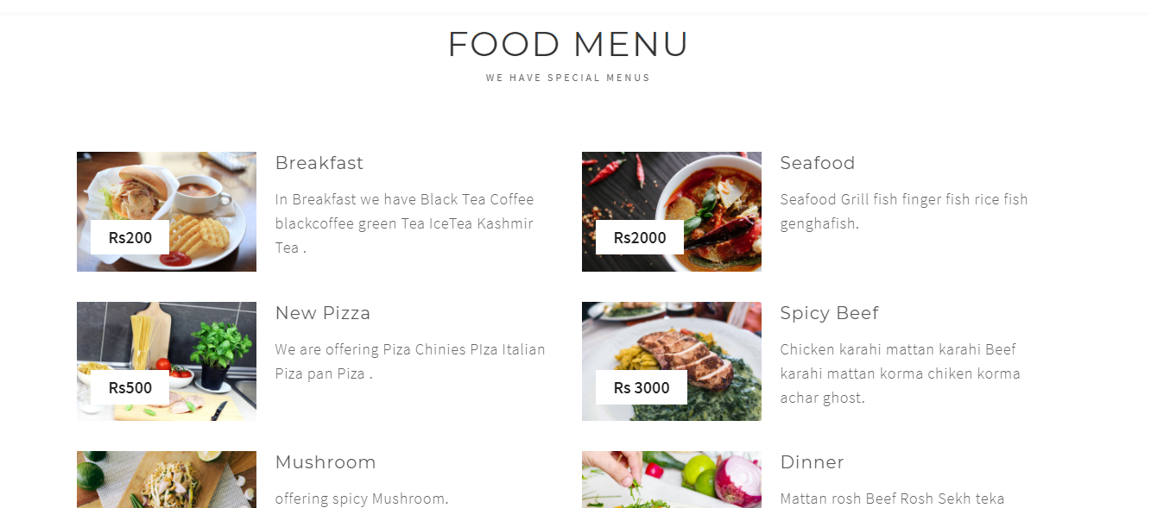

**Food Gallery**

The third part of the web is the gallery in which all picture and product will be added in the website.

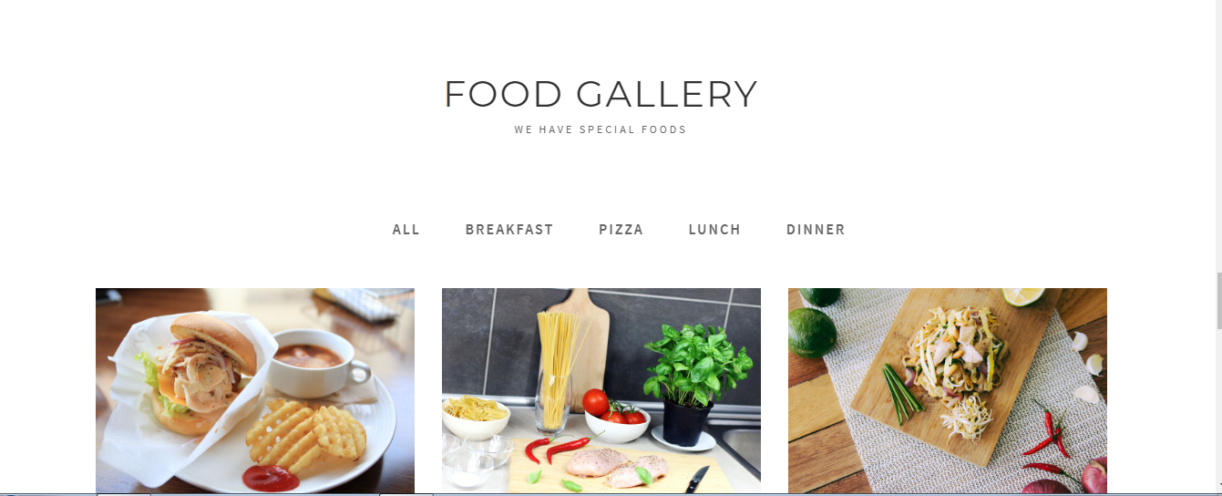

**Contacts**

The forth one is the contacts of the websites on which customer will contact for online selection of food items. On this contact page message has been send to the house after choosing the food items.

The snapshot is given below.



**Videos**

In this website videos of the item is also available for the customer in which they can select their favorite food.

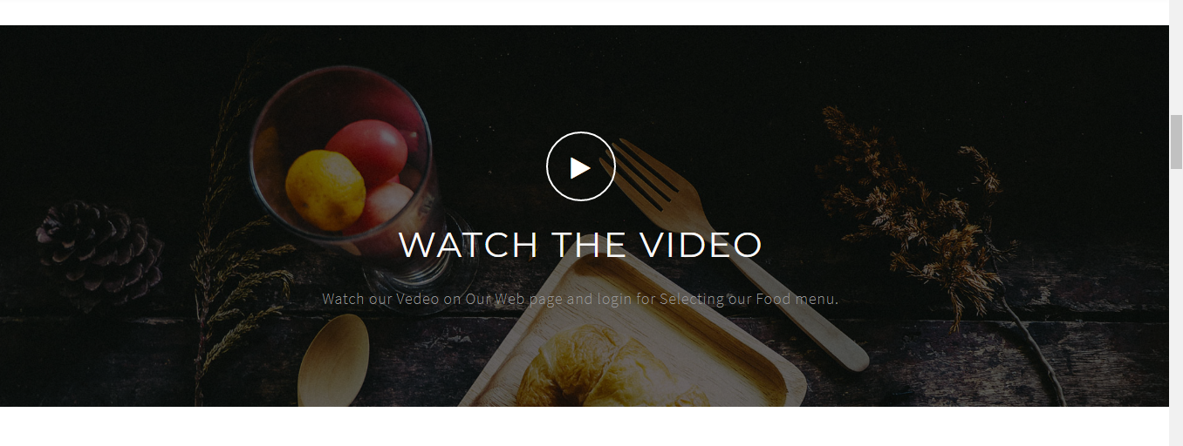

**Stories**

Different stories of the food and about the house will be added in the website.

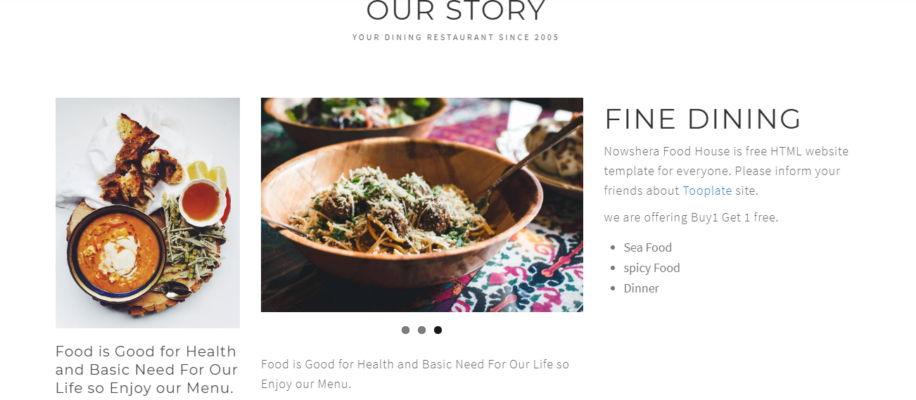

Why choose the Malakand food house

The comment area for the customer is available in the web because the customer can comment about the food and about the house.

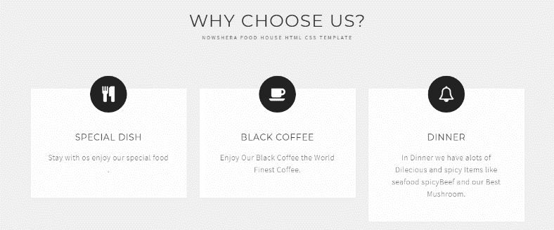

**Our chefs**

In the profile of the house we added our chefs and manger their name and picture.

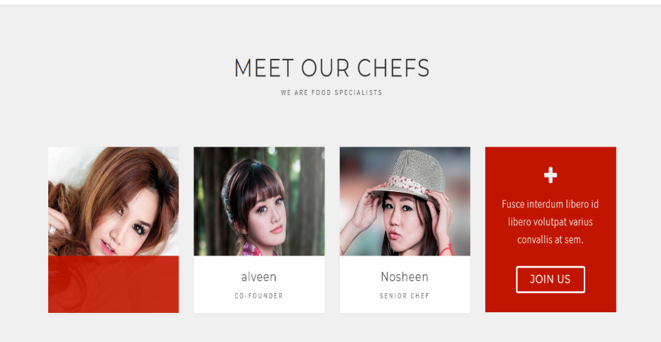

**Chapter 4**

**Testing and Delivery**

**_________________________________________________________________**

Content of the chapter

* + - * + System testing
        + Develop testing
        + Testing Strategies
        + Installation and delivery
        + Proposed change over

**System testing**

System testing is carried out whether the developed system is working according to the desired specification and requirement or not.

The system is checked using the actual data values. Also the reports and queries generated by the system are checked against requirement.

**Developed system testing**

All these strategies are adopted during the testing of the developed system the working of the system is almost perfect.

**Testing strategies**

Development of software system involves a series of production activities where opportunities for injector of human fallibility are enormous.

The basic testing strategies are is following.

1. Unit testing

In the unit testing different modules of the system is tested separately.

1. Integration testing

After the unit testing all the modules are combined and tested at the same time. We have tested our system in the integrated form was also working correctly.

**Installation and delivery**

Installation and delivery is the process of replacing the present system with the newly developed system. System installation is divided into two step.

1. Testing
2. Conversion/ changeover

**Testing**

Testing the system before actually replacing is very important. Testing is the process of making it sure that new system works accurately in actual data and gives right and exact result to the user.

In this approach the old and new system works concurrently. The old system runs until the new system has been proved accurate. The old system is available as a backup in the case of failure of the new system.

In the development of Malakand food house with the help of this the customer can buy food easily on the website selection of food is easy for the customer also delivery of the food is easy for the house staff it is the easy and reliable way for business as well as for the customer.